**CI/CD pipline project:**

**Steps to CI pipeline:**

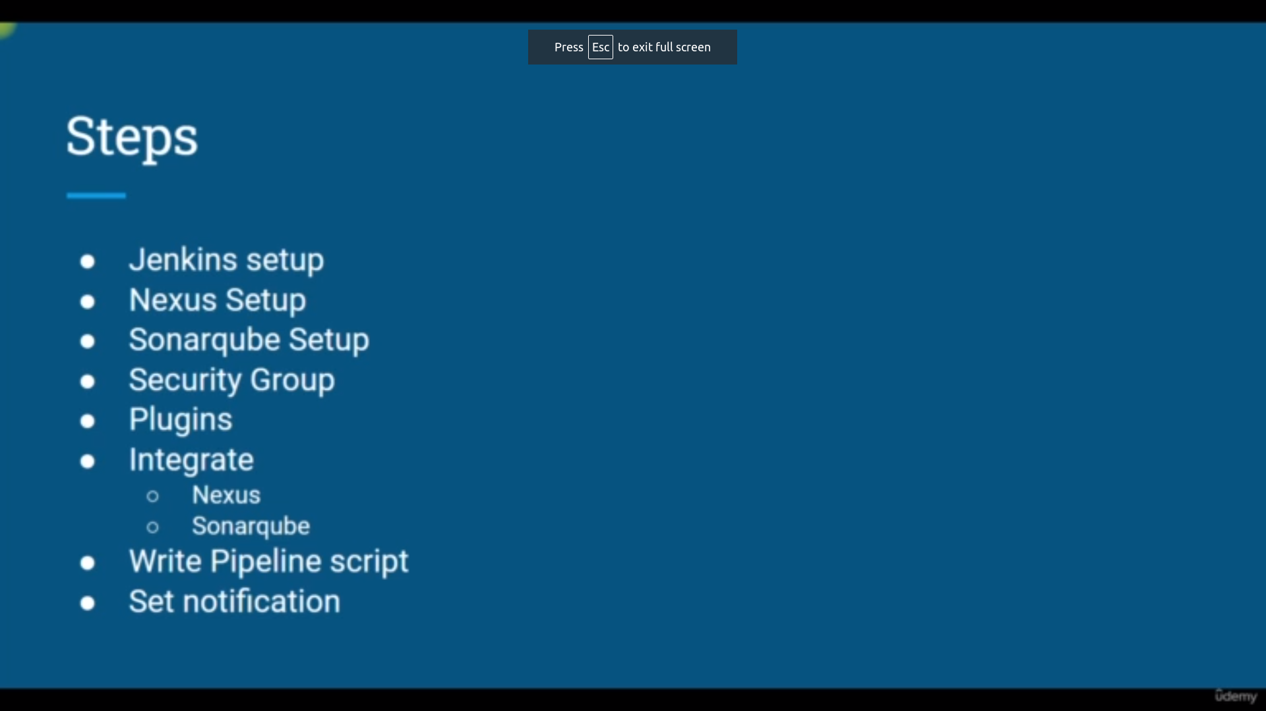

**Requirements:**

git repo link for setup above steps

**https://github.com/devopshydclub/vprofile-project/tree/ci-jenkins/userdata**

go to link and copy each userdata script and paste it on userdata

or use script in current directory

**SetUP[jenkins,sonarqube,nexus]:**

**Prequisites:**

**for jenkins:**

ubuntu 20

t2.small

10 Gib

port: 8080,80,22 must

**for nexus:**

centos 7[search in aws ami market place which is found after clicking on browse more ami’s]

t2.medium

10 gib

prots : 22,8080,8081

**for sonarqube:**

ubuntu 18

t2.medium

8 gib

ports: 22,80,9000 [actually it works in 9000 but it is used for internal communication with nginx 80 is enough]

After launcing instances and check they are running

ipaddress:8080 → jenkins

ipaddress:8081 → nexus

ipaddress:80 [or direct ipadress] → sonarqube

login and create user and password in each service [for sonarqube directly login with username: admin password: adim]

**Plugins:**

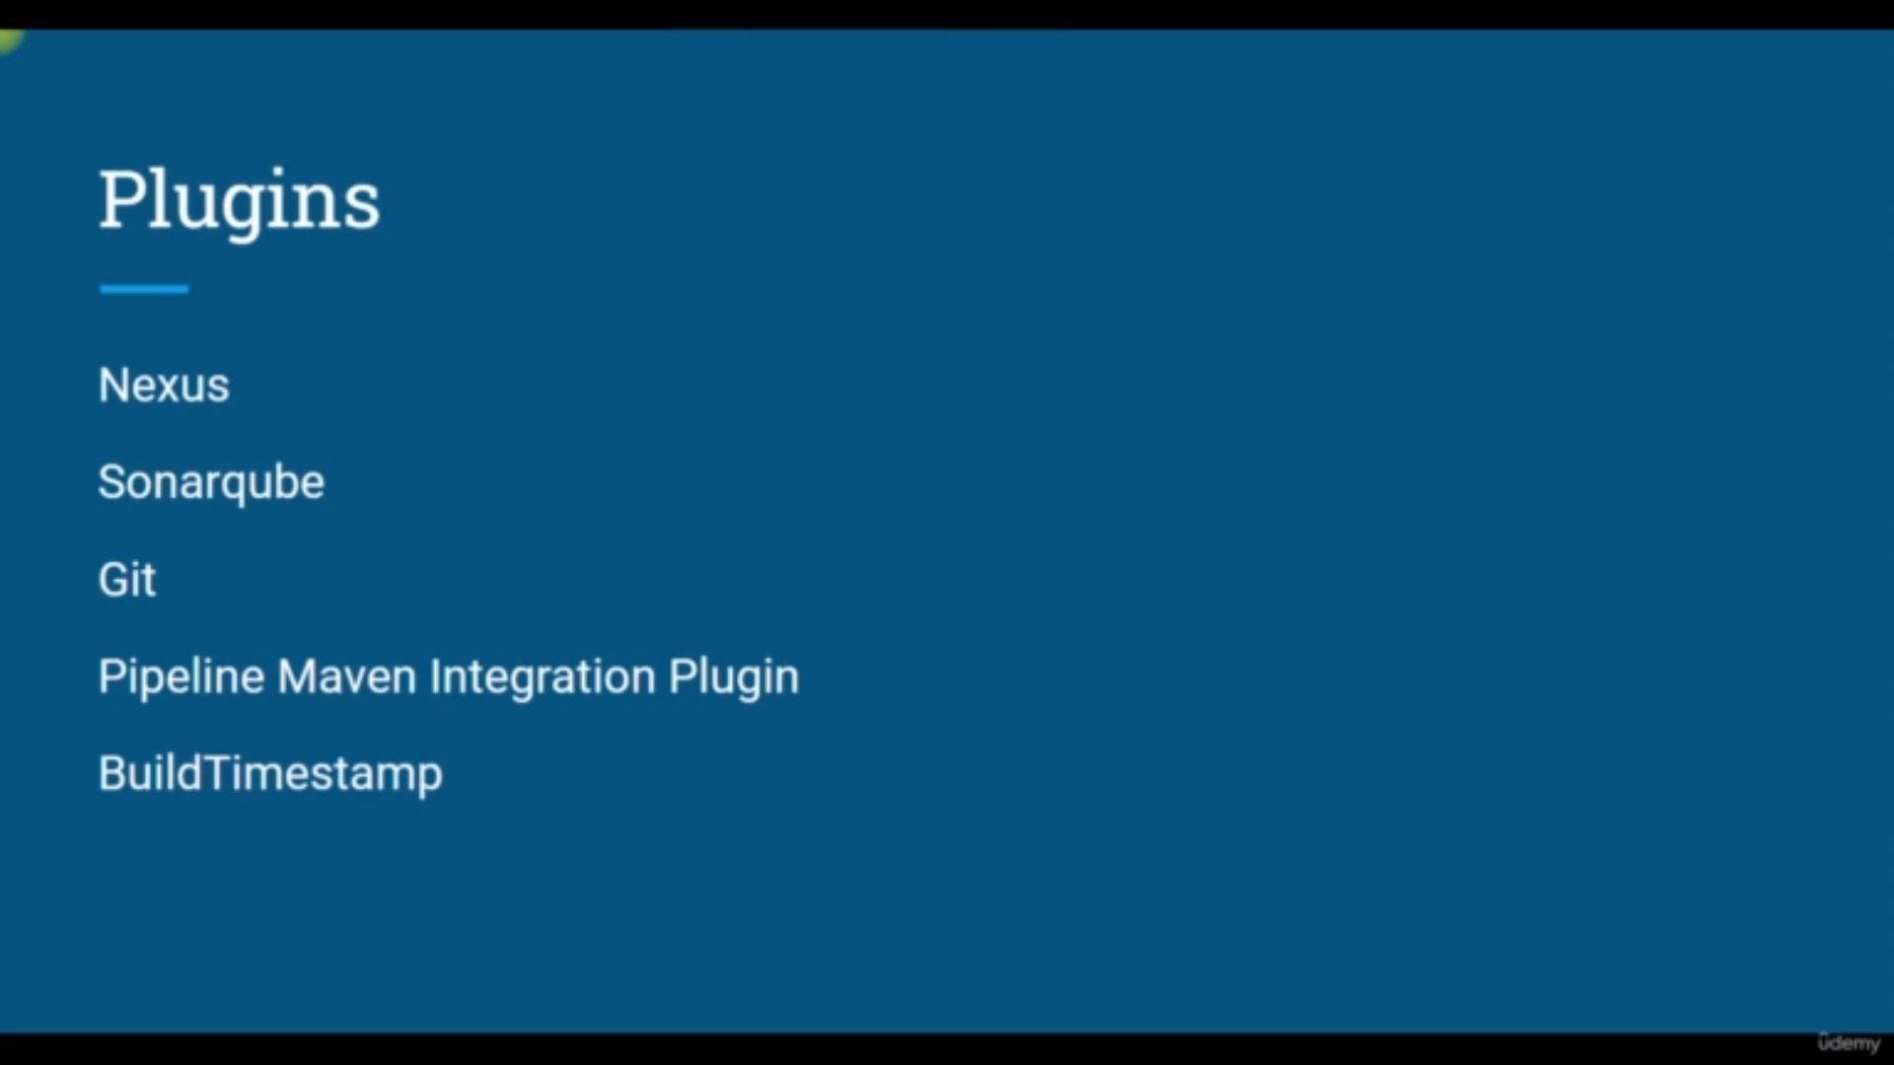we need above plugin and also more as of now these are mandatory

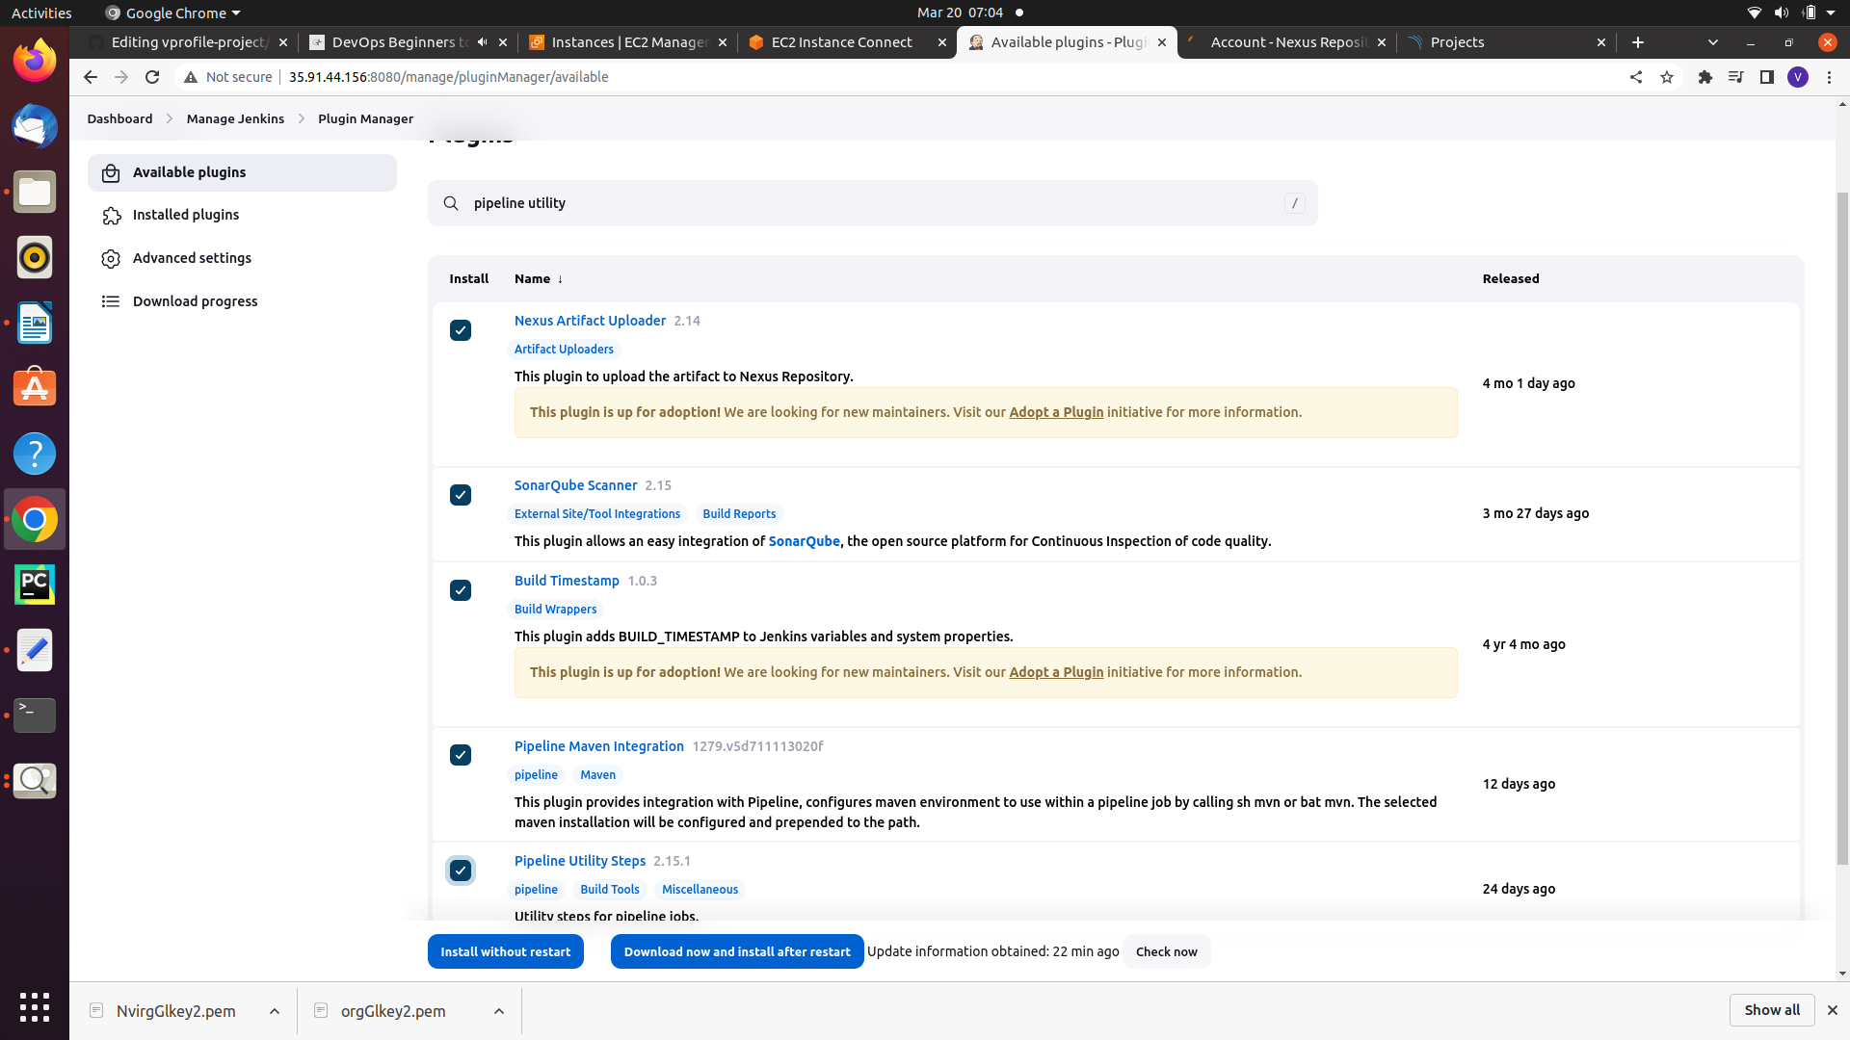just install above plugin in jenkins

**Pipeline as a Code:**

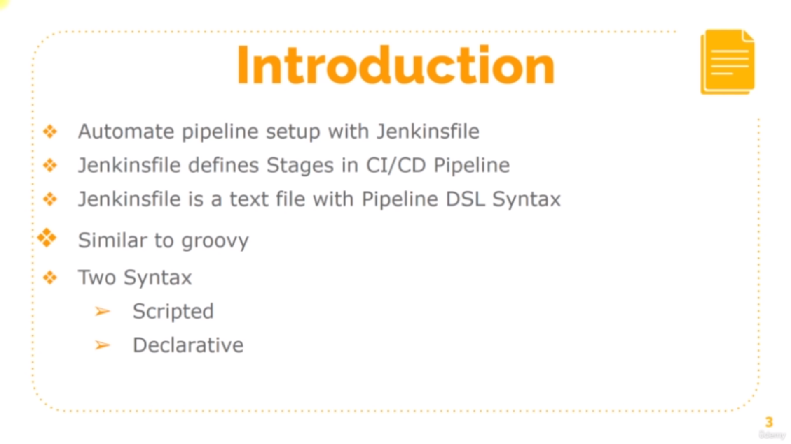

**step1:** create new job

**step2:** give job name and select pipeline

**step3**: write the jenkins file or kind of groovy language in pipline script

piplecode explanation:

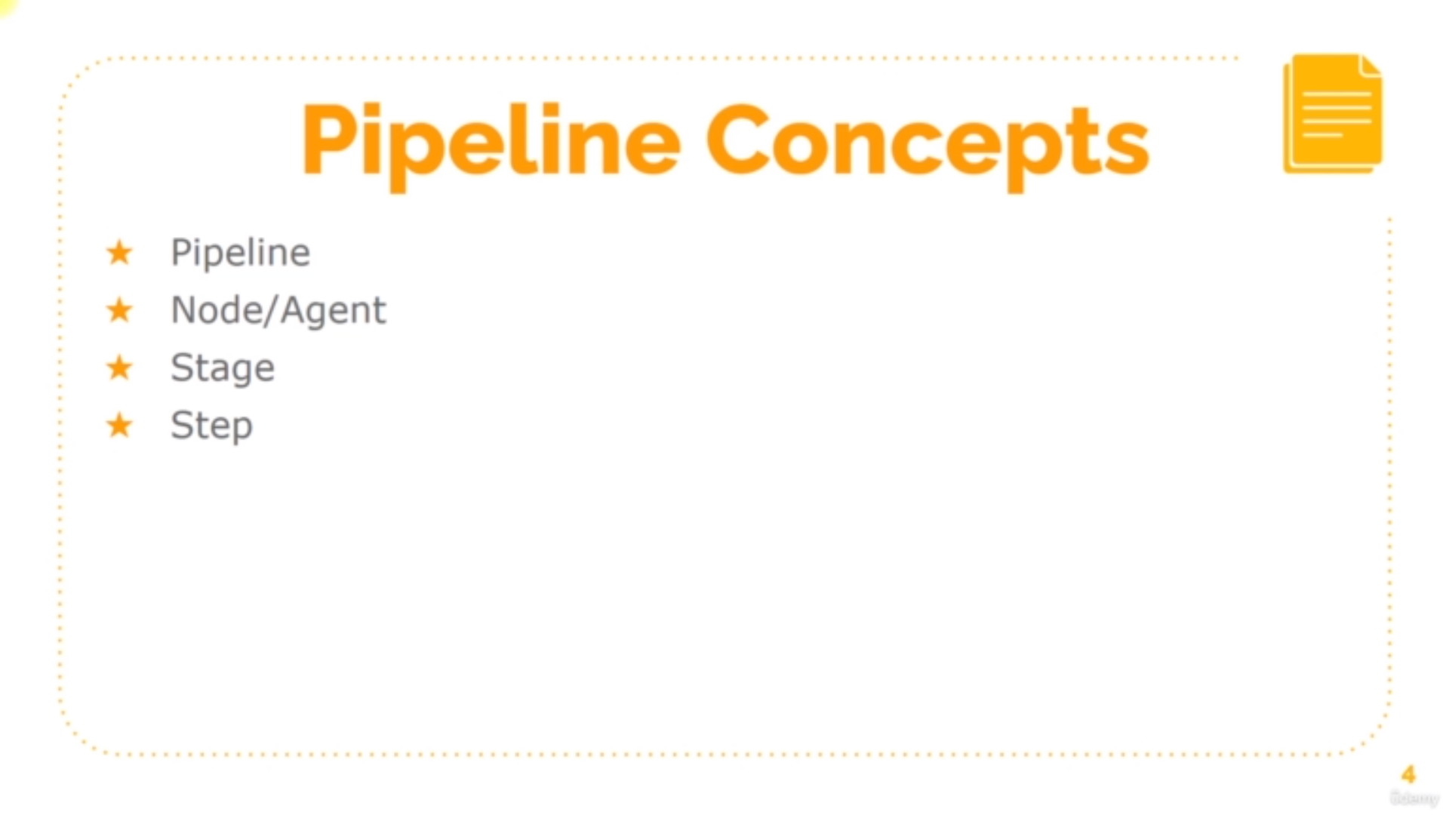pipline syntax steps

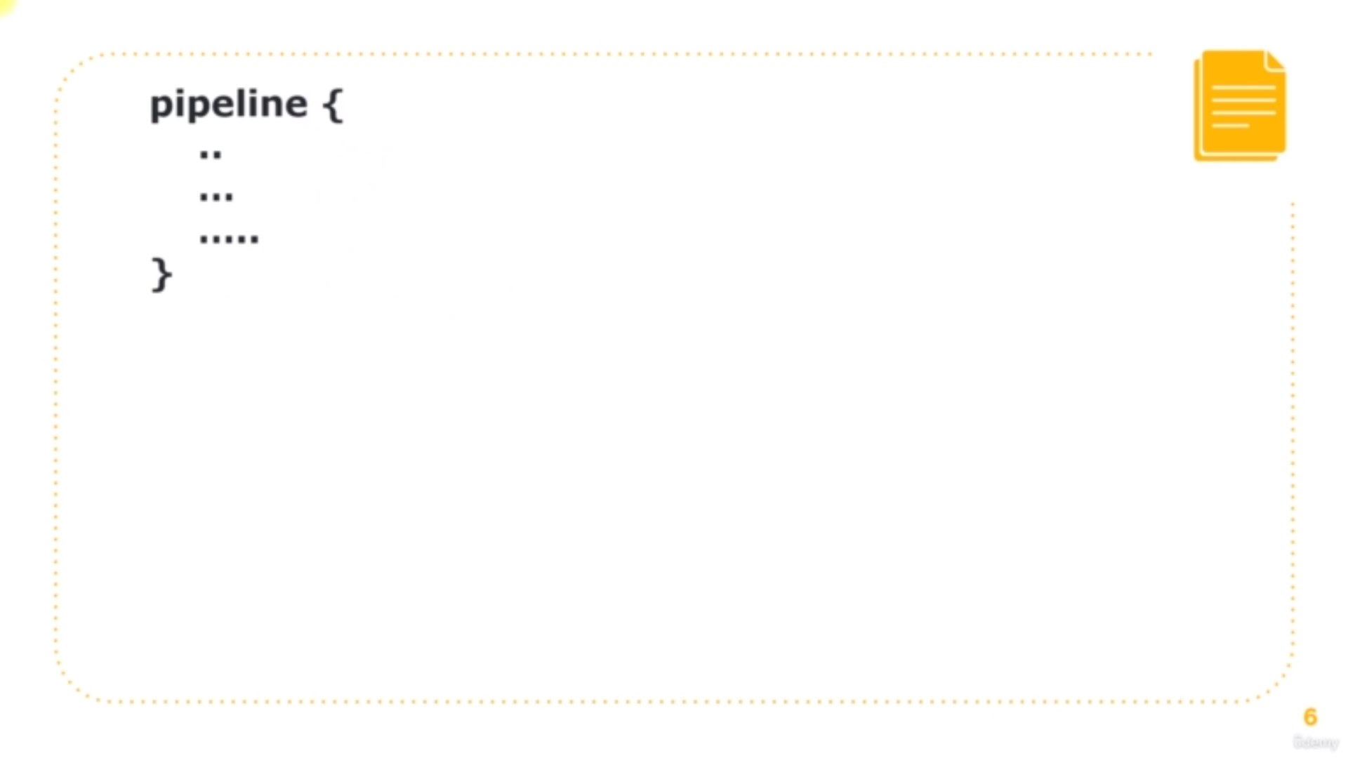we have root function or main function as pipline

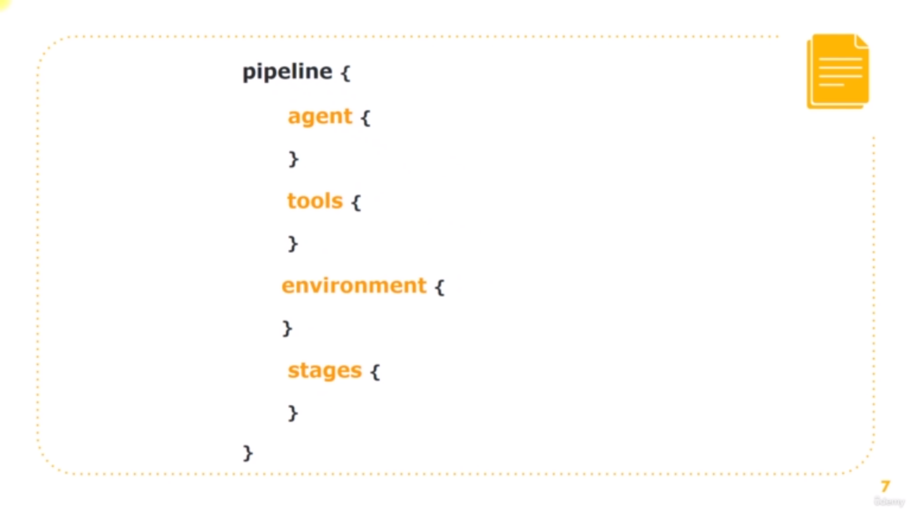In pipeline we have funtions as shown in above image

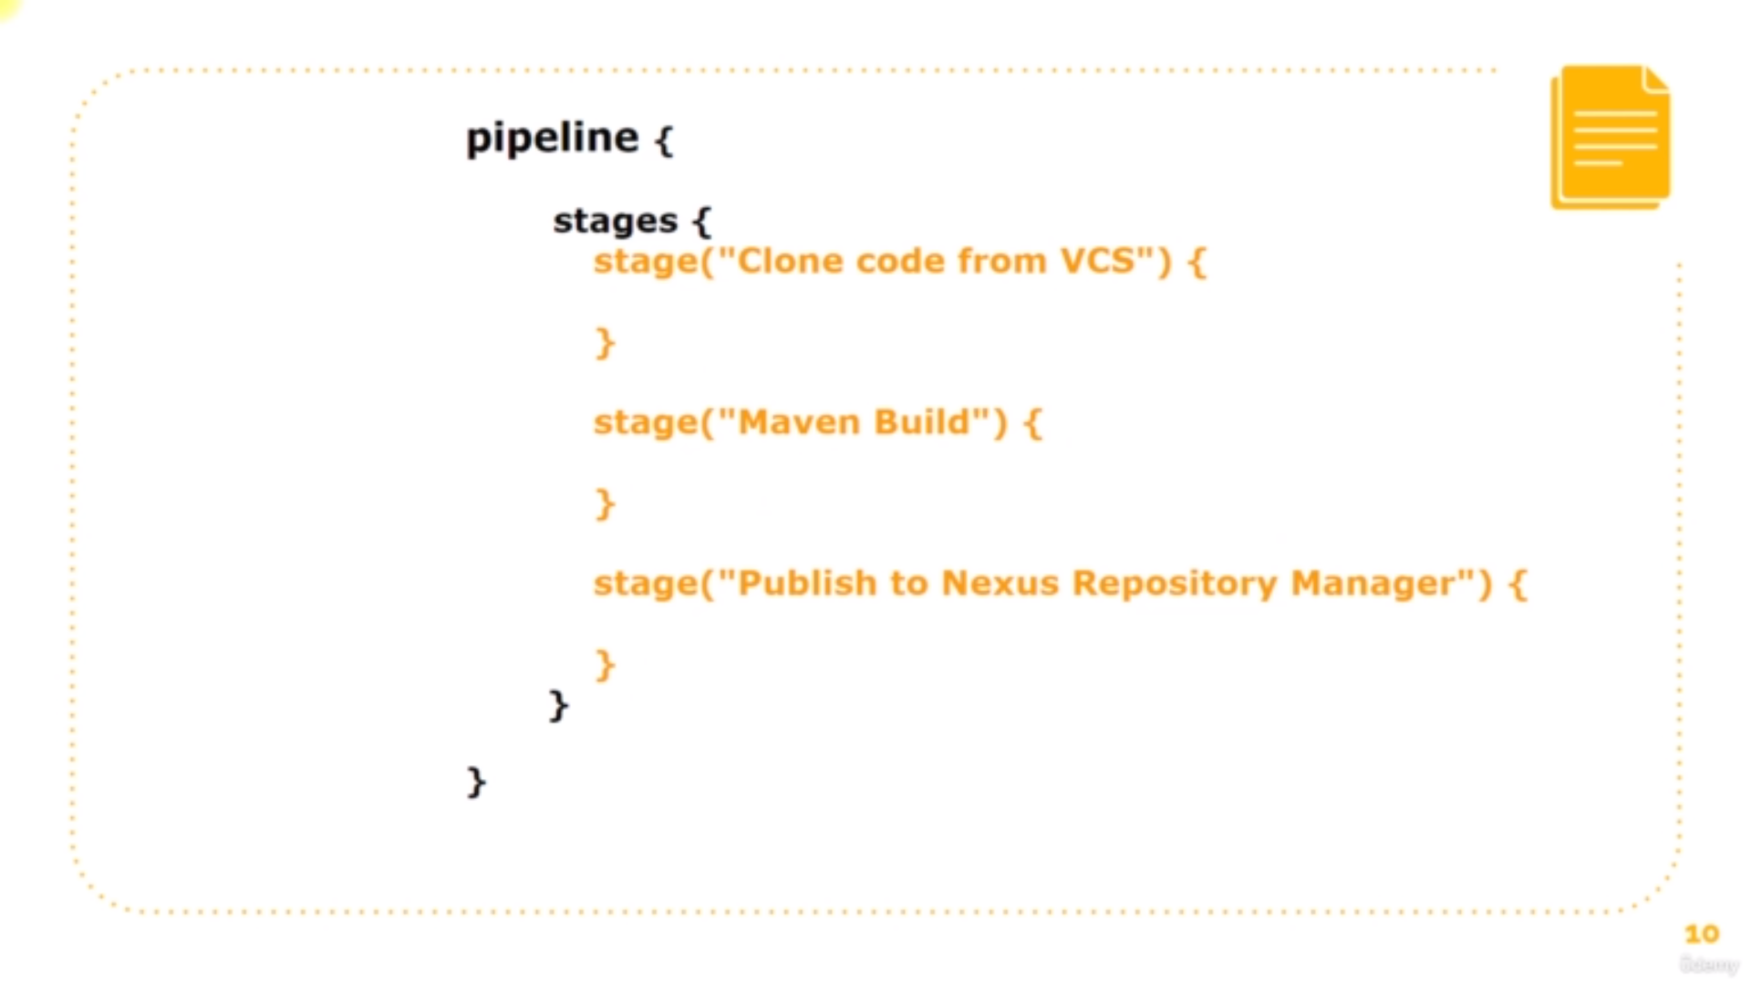in stages function we have stage function

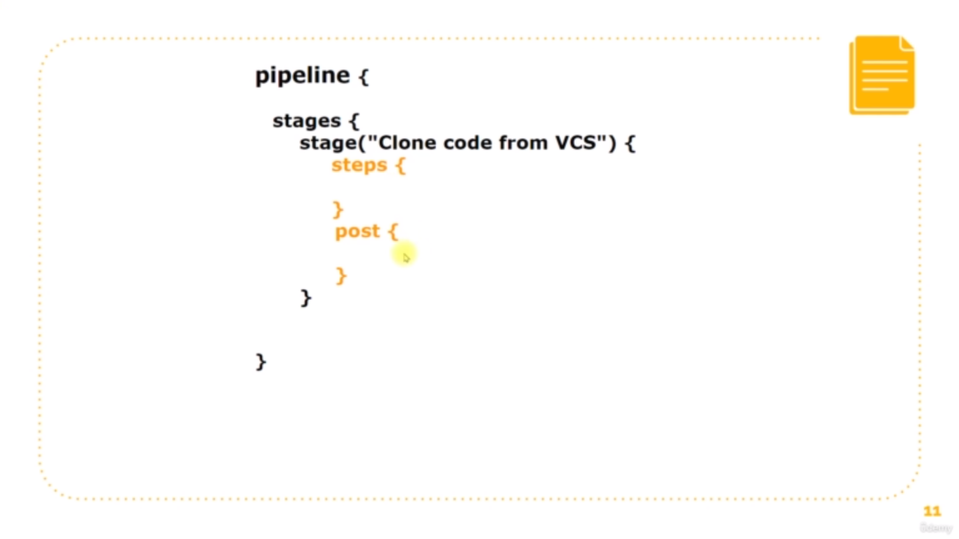each stage have steps where we define what to do like fetching the code from git

and also post function where we define what to do after doing the step function

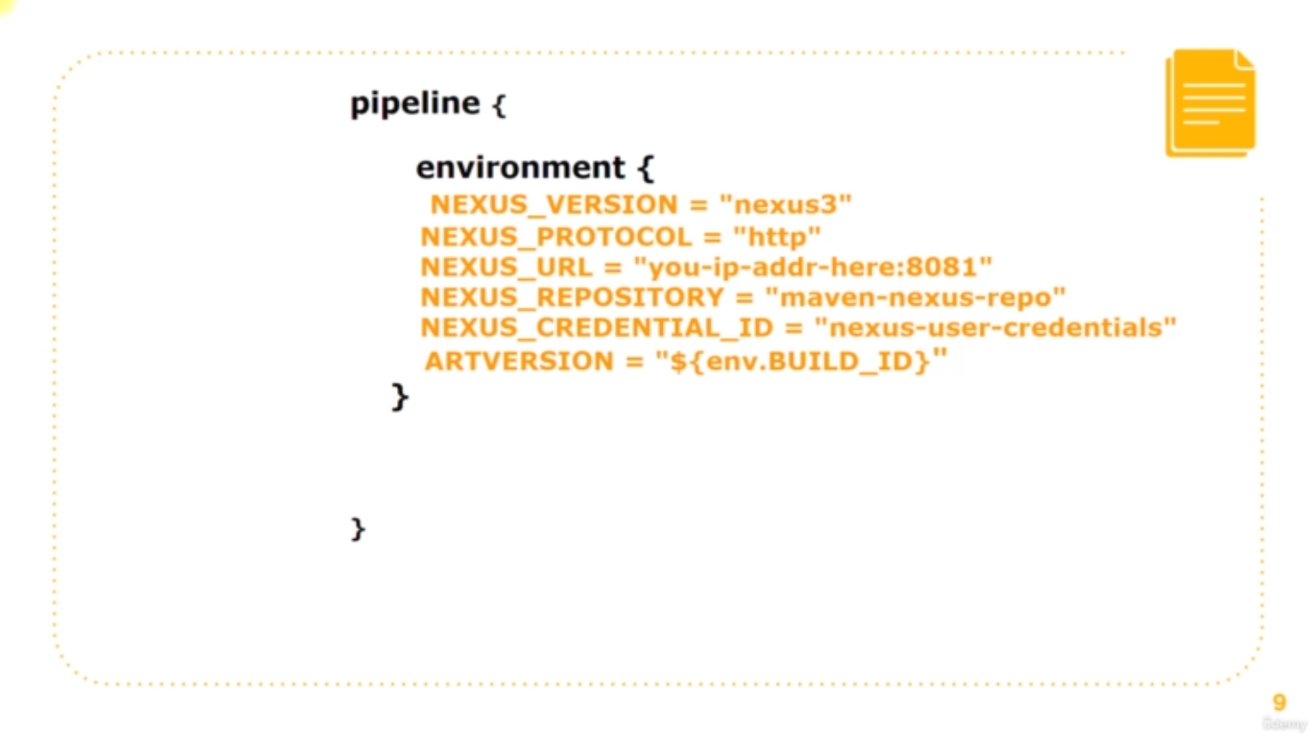in enviroment funcion we declare the credentials and detaails of tools

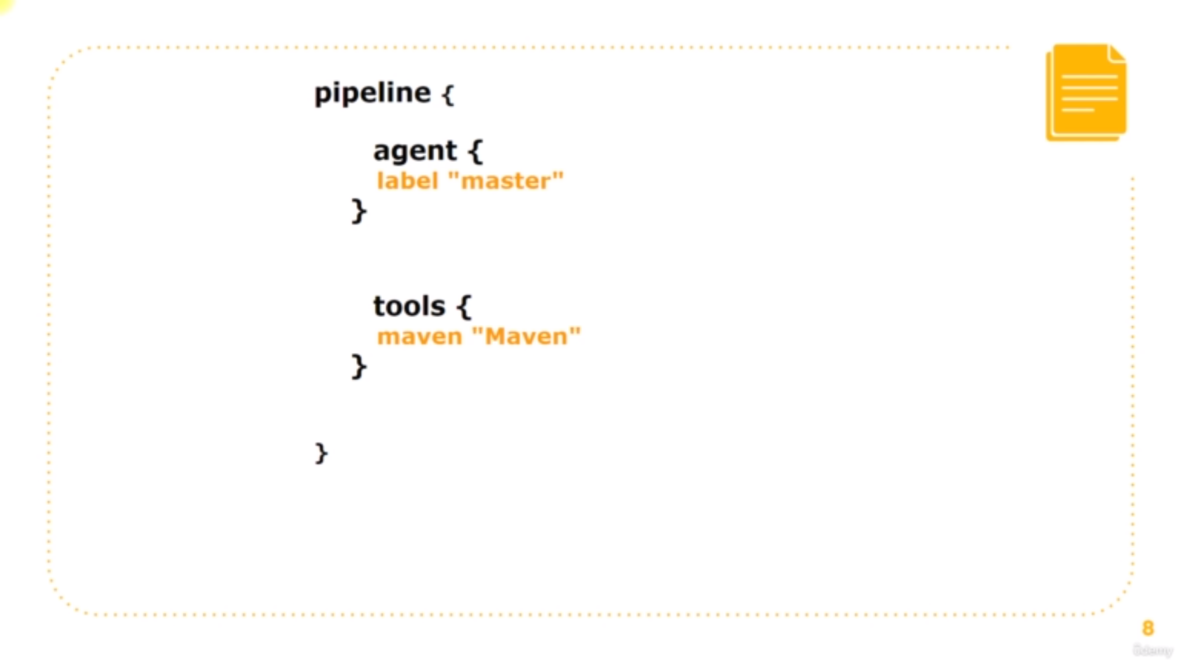in agenet function we declare on which instance or node we have to exceute stages

In tool function we declare which tool to be installed while doing stages like[maven]

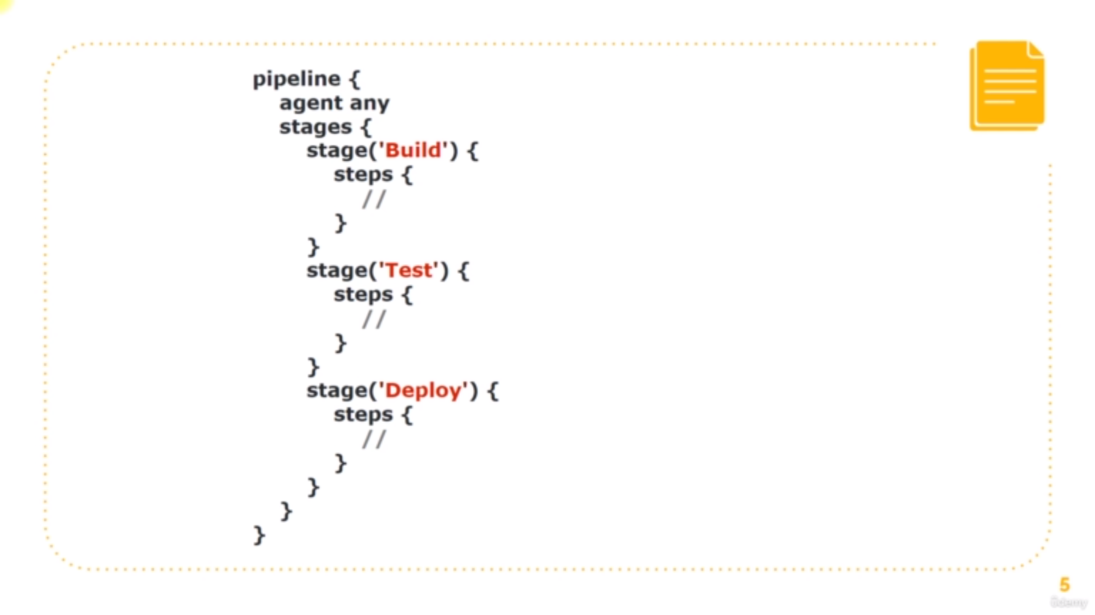sample script

**Code:**

**Explanation:**

**--------------------------------------------------------------------------------------------------**

**pipeline{**

**agent any**

**tools{**

**maven "maven3"**

**jdk "jdk8"**

**}**

**--------------------------------------------------------------------------------------------------**

here we declare agent and tools maven and jdk with the name of it maven3 and jdk8 which are there in Global tool configuration

**--------------------------------------------------------------------------------------------------**

**stages{**

**stage("fetching the code"){**

**steps{**

**git branch: 'vp-rem', url: 'https://github.com/santhoshgit8/vprofile-project.git'**

**}**

**}**

**--------------------------------------------------------------------------------------------------**

here in this stage we fetched the code and declare the branch and url parameters

**--------------------------------------------------------------------------------------------------**

**stage("build the code"){**

**steps{**

**sh "mvn install -DskipTests"**

**}**

**post{**

**success{**

**echo "Archieving"**

**archiveArtifacts artifacts: '**/target/*.war'**

**}**

**}**

**}**

**--------------------------------------------------------------------------------------------------**

here in this we added the build step which will build the code and also we added the post action where if the build the success it will archieve the results by the tool  **archiveArtifacts**

**-----------------------------------------------------------------------------------------------------**

**stage("unit testing"){**

**steps{**

**sh "mvn test"**

**}**

**}**

**}**

**-----------------------------------------------------------------------------------------------------**

**in this stage we are testing code by writing the below steps**

**Description:**

Upto this we are done with the unit testing which is normally done jenkin

machine

the next step is to add some other stages like

codeanalysis

**Codeanalysis:**

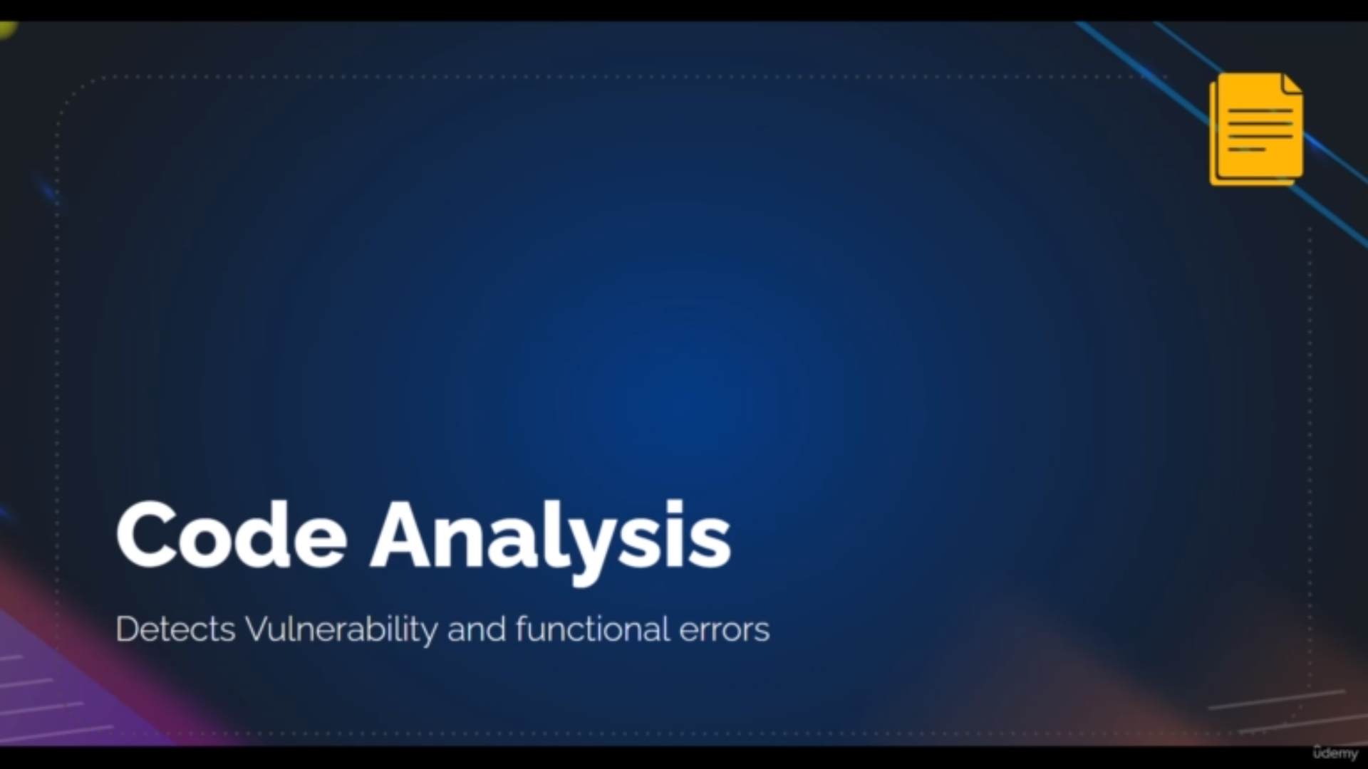basically code analysis is for testing the code

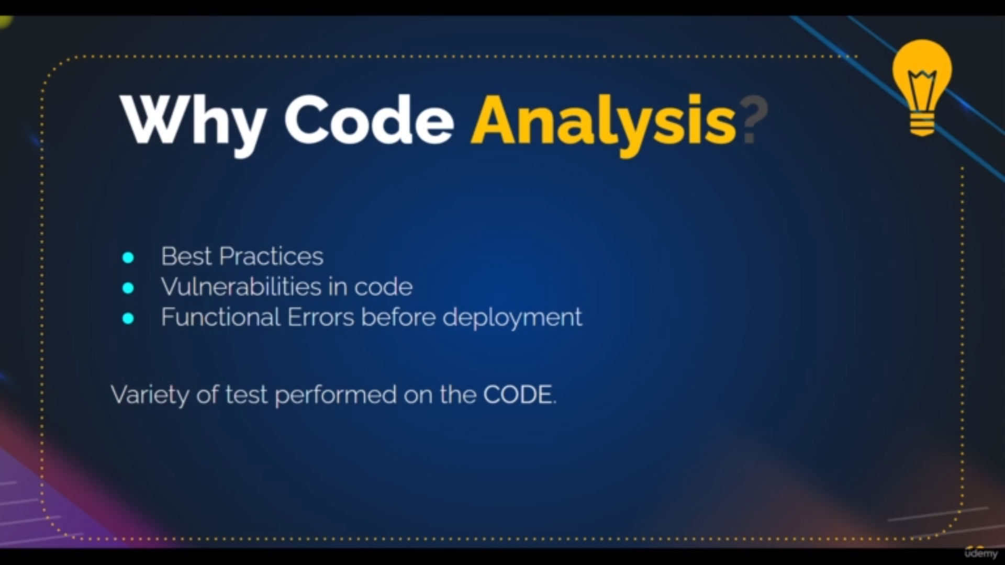these are tests that are done by code analysis

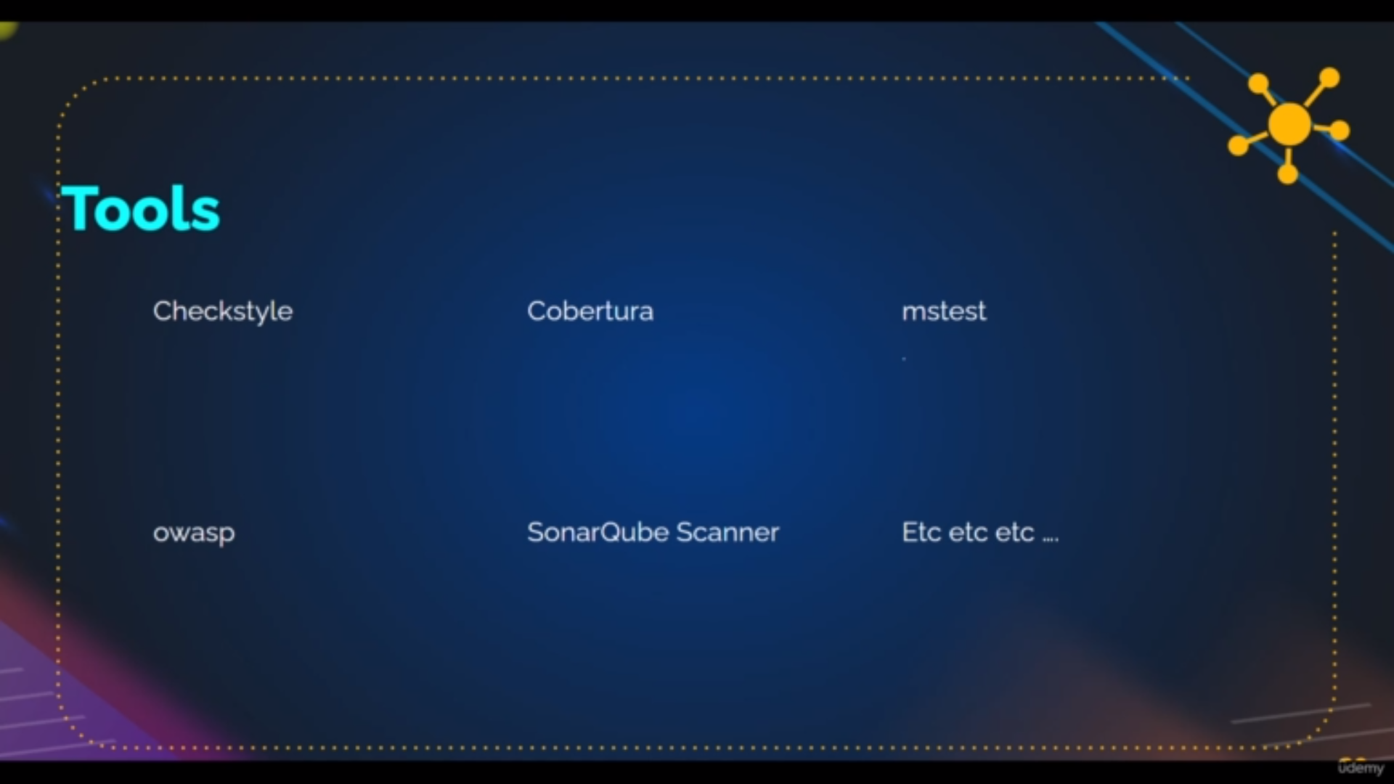tools that are used for codeanlaysis

here we are using checkstyle which is already there because of maven

sonarqubel scanner which we have to add the plugin and integrate

**Steps to integrate SonarQube**

step1: make sure you have the sonarqube scanner plugin in

manage plugin→ installed plugin

step2: After that add sonarqube tool with the version and name

in

manage jenkins→ Global tool configuration

step3: Now to integrate the our sonarqube server with jenkins

Go to

manage jenkins→ config system

there

a)add sonarqube scanner

b) check the box environment variables

c)give the name and

d)give the [http://sonarqube](http://sonarqube/)publicip

note: if we click on small add it is disable that is y we r saving the details and coming to same page

e)click on add whese select secret text and give the secret text {it is found on

sonarqube website→ click on dp→my account→ security tab→ generate token}

f) give the name and description for the token and save the token

after that save the config system

**Code:**

**Explanation:**

**--------------------------------------------------------------------------------------------------**

**stage("checkstyle conde analysis"){**

**steps{**

**sh "mvn checkstyle:checkstyle"**

**}**

**}**

**----------------------------------------------------------------------------------------------------**

**it is checkstyle analysis of code**

**Description:**

**Quality Gateway:**

we create the quality gatway to give some condition to the pipeline code to give the result as pass or fail

example:

Go to sonarqube website

click on Quality Gateway→ click on create→ give the name and click on save

→Add condition[select overall code and add metric for bugs where if bugs greate than 60 ]

click on save

click on projects → click on our project→ go to project settings → quality gateway

→ select the create quality gateway from dropdown

after getting detail for sonarqube those details have to send to jenkin using **web-hook** for this

click on projects → click on our project→ go to project settings → web-hook → create

→ fill the details as

**name:**jenkins-webhook

**url:** http:/ipadress:8080/sonarqube-webhook

and save it

**So** by this quality gateway if we have more than 60 bugs then our pipline code

show as failed and vice versa

**Code:**

**------------------------------------------------------------------------------------------------------**

**stage("Quality Gate") {**

**steps {**

**timeout(time: 1, unit: 'HOURS') {**

**// Parameter indicates whether to set pipeline to UNSTABLE if Quality Gate fails**

**// true = set pipeline to UNSTABLE, false = don't**

**waitForQualityGate abortPipeline: true**

**}**

**}**

**}**

**------------------------------------------------------------------------------------------------------**

in this stage we are setting quality gate and we are giving time that

sonar will give the bugs info to jenkins so that it can decide fail or success within time 1hr using web-hook

**Note:Give the private ip for every url becos whenever we shutdown our**

**ec2-instances public ip changes if we dont have elastion ip**

**Nexus[Repositery]:**

it is a tool which store our artifacts in versioning in a created repositery by us

so that ops team can download it and use it for further testing

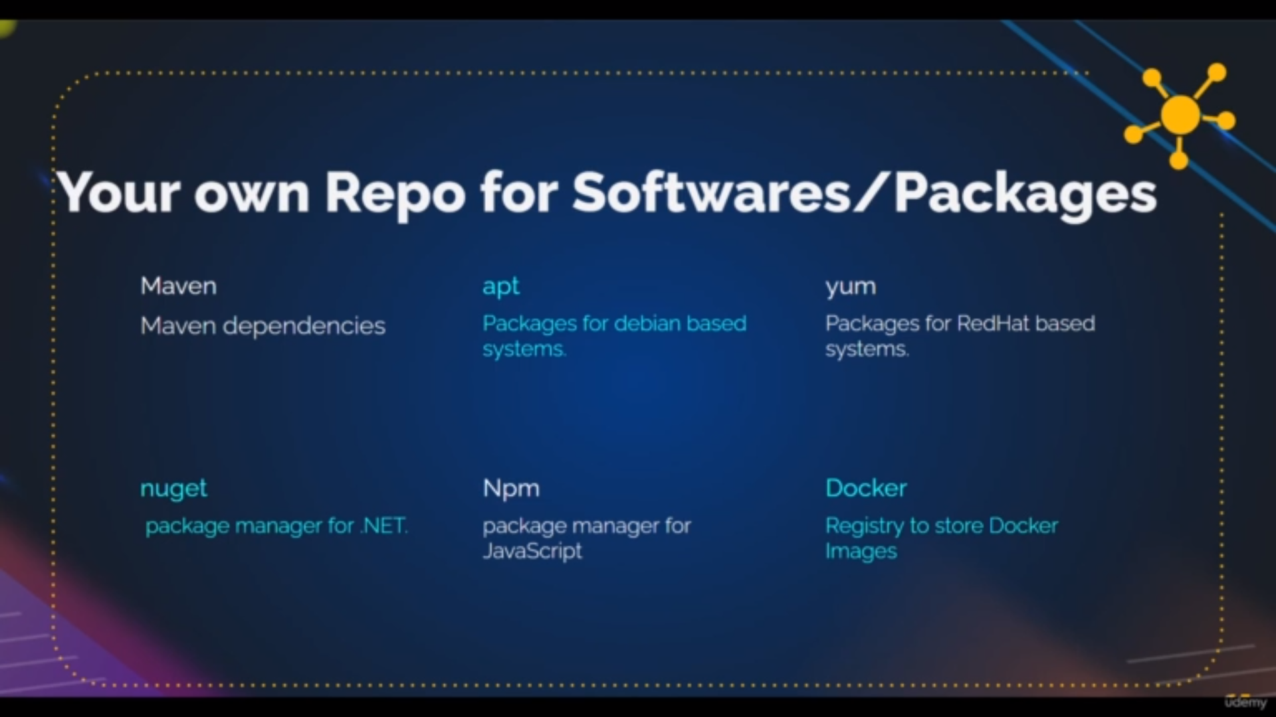repositeries

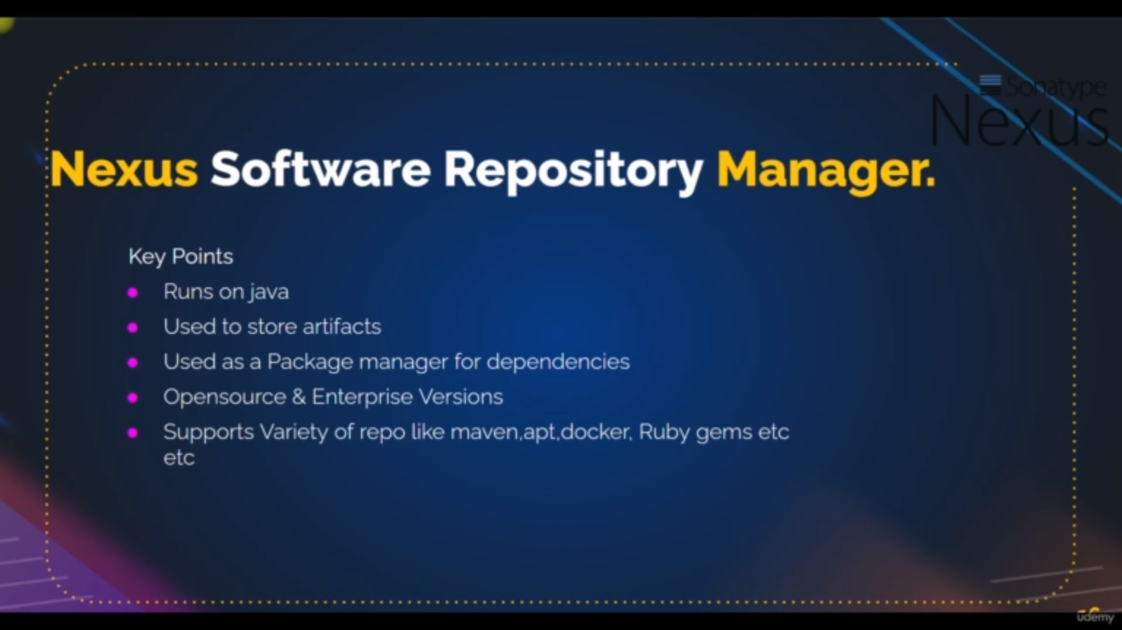advantages

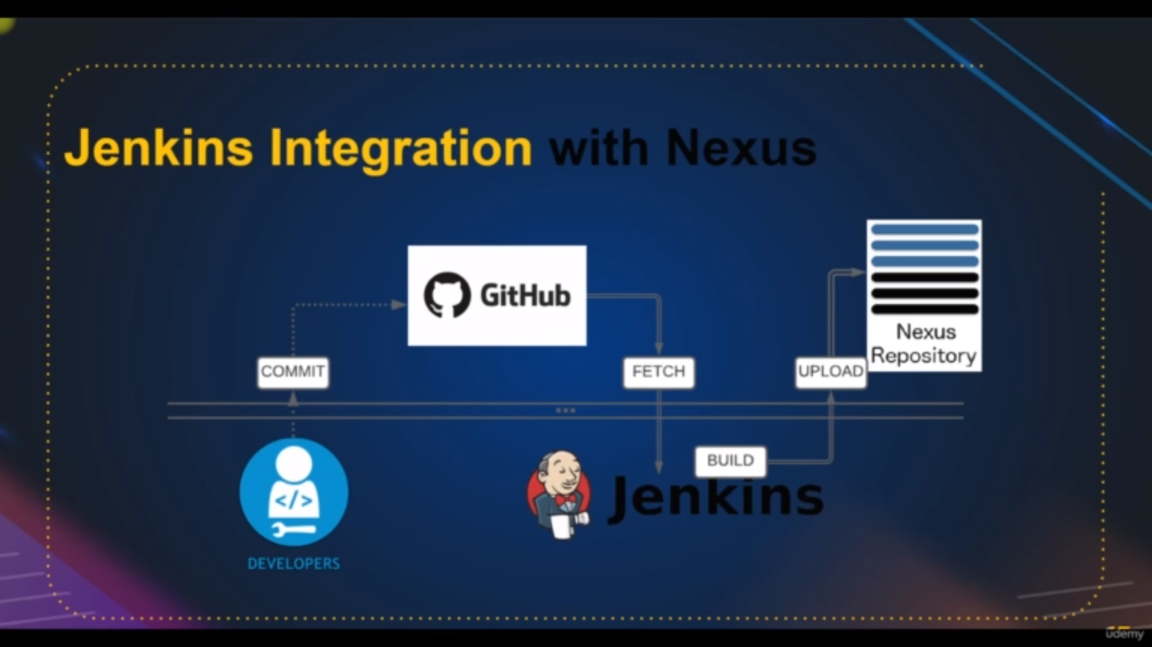flow to nexus repositery

Config nexus:

step1: make sure available of nexus in manage jenkins→ manage plugins→ installed plugins

step2: add the credention in

manage jenkins→ manage credetials→ system in store scoped to jenkins

→ globalcredentials→ add credential→ there give username and password and also

id and description

step3: login to nexus → click on settings icon→click on repositiries → add repositeries by adding name to it and click on create it

Note: To check our artifacts

click on browse[side to setting icon]→ click on browse→ click on your repository

there you’ll find our artifacts

**Code**

**Explanation:**

**----------------------------------------------------------------------------------------**

**stage("UploadArtifact"){**

**steps{**

**nexusArtifactUploader(**

**nexusVersion: 'nexus3',**

**protocol: 'http',**

**nexusUrl: '172.31.11.84:8081',**

**groupId: 'QA',**

**version: "${env.BUILD_ID}-${env.BUILD_TIMESTAMP}",**

**repository: 'vprofile',**

**credentialsId: 'nexus-login',**

**artifacts: [**

**[artifactId: 'vproapp',**

**classifier: '',**

**file: 'target/vprofile-v2.war',**

**type: 'war']**

**]**

**)**

**}**

**}**

**------------------------------------------------------------------------------------------------------In this stage we are providing the every details for the jenkins to store the artifacts in nexus repository**

nexus url : privateip:8081

groupid: anything

version: it is to maintaining the versions in nexus repository of different artifacts

repository: our created repository in nexus

credential: id of the crendtial that we are created in

manage jenkins→ manage credetials→ system in store scoped to jenkins

→ globalcredentials→ add credential→ there give username and password and also

id and description

artifacts: the way storing the our artifact in nexus repository

artifactid: anything [name of artifact in nexus repo ]

classifire: [file: (where our build war is located) and (type: in whicha we want to store in the nexus-repo]

**Description:**

**Notification to Slack:**

step1:login to the slack→ create new workspace → creat channel→ add members

step2: search “slack apps” on google → searhcb for jenkins in slack apps→ click on add to slack → select channel → **copy the token→**  click on save settings

step3: go to manage jenkins→ manage plugin → install slack notification

step4: go to manage jenkins→ config system → add slack → enter the workspace name → click on add credentials→ select secret text→ give the token and name and desc of credeitials and save it→ enter default channel and test the connection

if it pass

save the config system

fail

do it step1 to step4 again

**Code**

**------------------------------------------------------------------------------------------------------**

**def COLOR_MAP = [**

**'SUCCESS': 'good',**

**'FAILURE': 'danger',**

**pipline{**

**-----**

**----**

**stages{**

**stage{**

**steps{**

**------**

**}**

**}**

**post {**

**always {**

**echo 'Slack Notifications.'**

**slackSend channel: '#jenkinscicd',**

**color: COLOR_MAP[currentBuild.currentResult],**

**message: "*${currentBuild.currentResult}:* Job ${env.JOB_NAME} build ${env.BUILD_NUMBER} \n More info at: ${env.BUILD_URL}"**

**}**

**}**

**--------------------------------------------------------------------------------------------------**

from line 1 to 3

we are defining that if we get build succes give the greeline in slack

if we get build falure give the redline in slack[good=green,danger-red]

in post stage:

we are giving that **always** send the notification

to the channel **'#jenkinscicd',** alongwith the color and message which is having

result ,jobname,build number and jenkin log url

**Steps to store aws ecr using docker instead of nexus:**

installing docker on jenkins

add jenkins to docker group so that it jenkins has permission to use docker

install aws cli

create a user with Amazonec2containerregistry full access and

Amazonecs_full acces

create amazon ecr [steps:give the name and make it private and click on create]

install plugins in jenkins

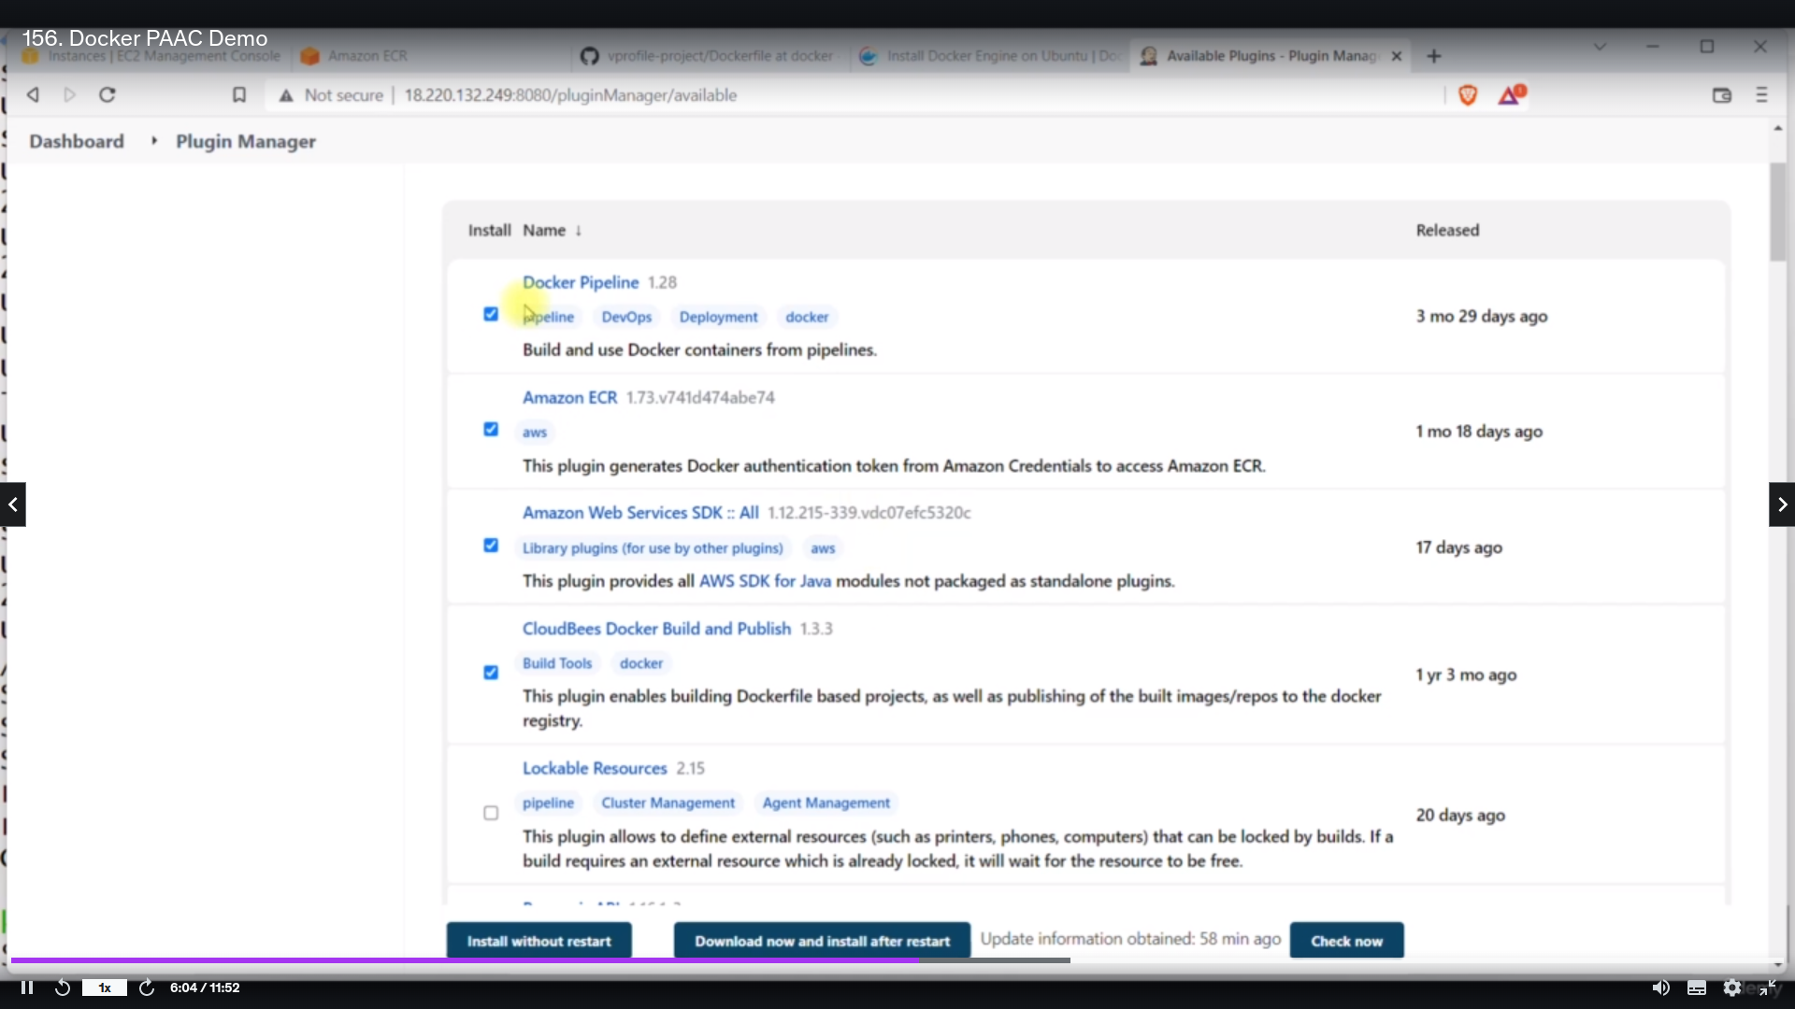plugin to install

Give aws credentials in manage credentials

**Aws Ecs step:**

**creating cluster:**

step1: go to ecs and click on cluster

step2: give the cluster name and enable use container insights in monitering and save

**creating taskdefinition:**

step1: go to ecs and click on taskdefinition

step2: give task definition name

step3: give the contaner name and image uri name[uri can found in aws ecr **imageuri** copy paste it]

step4: give the port no 8080 [since we are exposing the container image as tomcat server in docker file

which is found in our github repo there we are exposing the container at

8080 port] and click on next

step4: provide the details of ram and rom etc[orelse defalut] and click on next and click on create

**creating service:**

**step1:**in ecs page go to cluster and click on created cluster

stpe2: click on service tab and click on deploy

step3: select the family as above tastdefinition

step4:click on loadbalancing and give any name to it

step5: add the listener as 80 that load balancing should listen and target group name and select protocol as http and also give the health check path [url where thehelath check]

step6: add the security group for load balancer in networking and add rule

80 [listener port]allowed from anywhere and save it

step7: click on deploy

Note: if health check is unknown then Go to the target group and click on target group and go to health checks tabs where if it is unhelathy

Try to edit and make the traffic port as override and give your container port [8080]

Apart from this update the security group of loadbalancer as

allow port 8080 from anywhere

**plugins in jenkins:**

Add plugin **Pipeline:aws steps** in jenkins

Add the job and add pipeline script and build the job

For acessing the website

go to ecs → click on cluster→ click on your cluster → click on service tab → click on your service→ click on load balancer url

**Code**

**Explanation:**

**----------------------------------------------------------------------------------------------------**

**environment {**

**registryCredential = 'ecr:us-west-2:awstoken'**

**appRegistry = "376314486434.dkr.ecr.us-west-2.amazonaws.com/vprofile"**

**vprofileRegistry = "376314486434.dkr.ecr.us-west-2.amazonaws.com"**

**cluster = "vprofile"**

**service = "vprofileappsvc"**

**}**

**----------**

**--------**

**--------**

**stage('Build App Image') {**

**steps {**

**script {**

**dockerImage = docker.build( appRegistry + ":$BUILD_NUMBER", "./Docker-files/app/multistage/")**

**}**

**}**

**}**

**stage('Upload App Image') {**

**steps{**

**script {**

**docker.withRegistry( vprofileRegistry, registryCredential ) {**

**dockerImage.push("$BUILD_NUMBER")**

**dockerImage.push('latest')**

**}**

**}**

**}**

**}**

**stage('Deploy to ecs') {**

**steps {**

**withAWS(credentials: 'awscreds', region: 'us-east-2') {**

**sh 'aws ecs update-service --cluster ${cluster} --service ${service} --force-new-deployment'**

**}**

**}**

**}**

**stage1: environment:**

where we credential id’s and uri’s that we mention in aws and manage credeitionals

**stage('Build App Image') :** it will build the docker image for docker file which is there in docker repository

**stage('Upload App Image'):**we will upload the image to ecr repository

**stage('Deploy to ecs') :** we will create the container form the image which upload to ecr by above **stage('Upload App Image')**